Sal f
Golden Valley High School
Wm. S. Hart Union High School District
“Home of the Grizzlies”

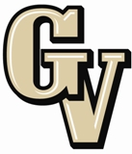

Special Education Information Meeting
October 14, 2013
6:30 PM

AGENDA

- Meeting Welcome Sal Frias

- Transition Based Career Education (SC 2 & 8) Sharon Amrhein

- Circle of Friends Joel Nelson

- Life Skills Lab Update Sal Frias

- Common Core and Special Ed Sal Frias

- Parking Lot and Traffic Pattern Update Joel Nelson

- District Policies

- School Safety

The mission of GVHS is to provide a quality education to a diverse student population, develop each student’s maximum potential, and prepare students for success in the global community.

